A

PROJECT REPORT

ON

**“ONLINE EXAMINATION MANAGEMENT SYSTEM”**

BY

**JAYANTI PANDURANG ROKADE**

**ROLL NO. 23516**

SUBMITTED TO

**SAVITRIBAI PHULE PUNE UNIVERSITY**

IN PARTIAL FULFILLMENT OF THE REQUIREMENT

FOR THE AWARD OF THE DEGREE OF

**MASTER OF COMPUTER APPLICATION**

UNDER THE GUIDANCE OF

MS. NEETA RASKAR

THROUGH

**SADHU VASWANI INSTITUTE OF MANAGEMENT STUDIES FOR GIRLS**

6, KOREGAON ROAD, PUNE 411001

2024-25

**DECLARATION BY STUDENT**

To,

The Director,

SVIMS, Koregaon Park, Pune

I, undersigned hereby declare that this project titled, “**ONLINE EXAMINATION MANAGEMENT SYSTEM”** written and submitted by me to SPPU, Pune, in partial fulfilment of the requirement of the award of the degree of **MASTER OF COMPUTER APPLICATION (MCA-II)** under the guidance of **Ms.** **Neeta Raskar,** is my original work.

I further declare that to the best of my knowledge and belief, this project has not been submitted to this or any other University or Institution for the award of any

Degree.

|  |  |
| --- | --- |
| **Place: Pune** |  |
| **Date:** | **(JAYANTI PANDURANG ROKADE)** |

**ACKNOWLEDGEMENT**

I am overwhelmed in all humbleness and gratefulness to acknowledge all those who have helped me to put the ideas, well above the level of simplicity and into something concrete.

I owe a great debt to my guide **Ms. Neeta Raskar** who provided wholesome direction and support to me at every stage of this work. Her wisdom, knowledge and commitment to the highest standards inspired and motivated me. My gratitude is also due to our Director **Dr. B H Nanwani**, for her unconditional support and guidance.

**Place: Pune**

**Date:**

**JAYANTI PANDURANG ROKADE**

INDEX

|  |  |  |
| --- | --- | --- |
| **CHAPTER** | **DETAILS** | **PAGE NO** |
| 1 | CHAPTER 1: INTRODUCTION   * 1. Client/Organization Profile   2. Need for System   3. Scope& Feasibility of Work   4. Operating Environment – H/w & S/w   5. Architecture of system   6. Detail Description of Technology Used |  |
|  |
|  |
|  |
|  |
|  |
| 2 | PROPOSEDSYSTEM   * 1. Proposed System   2. Objectives of System   3. User Requirements |  |
|  |
|  |
|  |
| 3 | ANALYSIS & DESIGN   * 1. DFD   2. Table specifications (Database)   3. ERD   4. Object Diagram   5. Class Diagram   6. Use Case Diagrams   7. Web Site Map Diagram (if Website) |  |
|  |
|  |
|  |
|  |
|  |
|  |
|  |
| 4 | USER MANUAL   * 1. User Interface Design (Screens etc.)   2. Limitations   3. Future enhancement |  |
| **5** | BIBLIOGRAPHY  ANNEXURE: SAMPLEPROGRAMCODE  Synopsis |  |
|  | Progress Report |  |

1. **INTRODUCTION**

Today **Online Examination Management System**has become a fast growing examination method because of its speed and accuracy. It is also needed less manpower to execute the examination. Almost all organizations now-a-days, are conducting their objective exams by online examination system, it saves students time in examinations. Organizations can also easily check the performance of the student that they give in an examination. As a result of this, organizations are releasing results in less time.

**Project Overview**

In an **Online ExaminationManagement System** examine get their user id and password with his/her admit card. This id is already saved in the examination server. When examine login to the server he/she get his/her profile already register. On the certain time examine gets the message to start the examination. All answers given by examine are saved into the server with his/her profile information. ***Online examination system***also allows to correct the answer if the examine needed to change any answer in the examination time duration, however, after the time duration any change will not allow. This also makes c checking the answer easy and error proof as computers are more accurate than man and provide fast results too. PHP is a web base language so we can create an ***online examination system in PHP***.

In the world of internet, all task has been done through internet, so we have decided why Exam has not conducted through internet. For convert current exam system into digital exam system, we have built this small Online Exam system project. If this system has built in professional level, then it will automate our existing examination system into digitize exam system. In this system it will required less labour force for execute system and it will be more accurate and less time consuming and at the same time we can conduct more person exam at the same time and it will publish result in a very short time. Below you can find benefits of Online Examination System. If this system has been implemented then examination will not limit in to four wall of class room, but student can part into exam from any place.

### **Online examination system features**

1. Login system must be present and secured by password.
2. Ability to save the answer given by the candidate along with the question.
3. Answer checking system should be available.
4. Could Update Profile
5. Log out after the over.
6. Admin Panel

**1.2) Need of System:**

An online examination management system (OEMS) is essential for several reasons:

1. **Accessibility**: Students can take exams from anywhere, removing the need for physical locations and accommodating diverse needs.
2. **Efficiency**: Automated processes for scheduling, conducting, and grading exams save time for educators and administrators.
3. **Scalability**: OEMS can handle large volumes of students simultaneously, making it suitable for institutions of all sizes.
4. **Security**: Online systems often include features like secure logins, proctoring, and plagiarism detection to ensure exam integrity.
5. **Data Analysis**: These systems can provide analytics on student performance, helping educators identify trends and areas for improvement.
6. **Cost-Effective**: Reducing the need for paper, printing, and physical resources lowers overall costs for educational institutions.
7. **Flexibility**: Different types of assessments (multiple-choice, essays, practicals) can be easily integrated into the platform.
8. **Immediate Feedback**: Students can receive instant results, enhancing the learning experience and allowing for timely interventions.

### **1.3)** **Scope and Feasibility of work**

1. **Scope of the System:**

The scope of an online examination system (OES) is vast and encompasses various aspects of education and assessment. Here are some key areas where OES can be applied:

1. **Educational Institutions**:
   * Schools, colleges, and universities can use OES for regular assessments, mid-term exams, and final examinations.
2. **Professional Certifications**:
   * Organizations offering professional certifications can implement OES for standardized testing and assessments.
3. **Corporate Training**:
   * Companies can use OES for employee training assessments, skill evaluations, and onboarding processes.
4. **Entrance Exams**:
   * OES can facilitate entrance exams for universities and colleges, allowing for larger candidate pools and easier management.
5. **Government Assessments**:
   * Government agencies can conduct civil service exams or other assessments online, increasing accessibility and efficiency.
6. **Distance Learning**:
   * OES is essential for distance education programs, enabling remote assessments for online learners.
7. **Customization and Flexibility**:
   * OES can be tailored to specific subjects, types of questions (MCQs, essays, etc.), and assessment criteria.
8. **Data Analytics and Reporting**:
   * OES can generate detailed reports on student performance, helping educators and institutions analyze results and improve teaching strategies.
9. **Accessibility Features**:
   * OES can include accommodations for students with disabilities, such as screen readers or adjustable time limits.
10. **Real-time Monitoring and Proctoring**:
    * Advanced features can include remote proctoring, AI monitoring, and other security measures to maintain exam integrity.
11. **Feedback Mechanisms**:
    * Immediate feedback on assessments helps students learn from their mistakes and understand their performance.

Overall, the scope of an online examination system extends across various sectors and applications, enhancing the assessment process in education and professional settings.

### **Feasibility of the Project:**

The feasibility of an Online Examination Management System (OEMS) can be assessed through several key dimensions:

### 1. **Technical Feasibility**

* **Infrastructure**: Evaluate the existing IT infrastructure. Adequate hardware and internet bandwidth are crucial for supporting an OEMS.
* **Software Requirements**: Consider the availability and compatibility of software. The system should be user-friendly, secure, and scalable.
* **Integration**: Assess the ease of integration with existing Learning Management Systems (LMS) and other educational tools.

### 2. **Operational Feasibility**

* **User Training**: Determine the training needs for both administrators and users (students and educators) to effectively use the system.
* **Support Services**: Availability of technical support to address issues during exams and ensure smooth operation.
* **User Acceptance**: Gauge the willingness of students and faculty to adopt an online system versus traditional methods.

### 3. **Economic Feasibility**

* **Cost Analysis**: Compare the costs associated with implementing an OEMS (software licensing, hardware, training) against the potential savings (reduced paper usage, time savings).
* **Budget**: Assess if the institution’s budget can accommodate the implementation and ongoing maintenance of the system.
* **Return on Investment (ROI)**: Evaluate potential benefits such as increased efficiency, improved student performance data, and enhanced examination security.

### 4. **Legal and Compliance Feasibility**

* **Data Privacy**: Ensure compliance with data protection regulations (e.g., GDPR, FERPA) to protect student information.
* **Accreditation Standards**: Verify that the online examination system meets the accreditation requirements for the institution.

### 5. **Cultural Feasibility**

* **Institutional Culture**: Consider the institution’s culture regarding technology adoption. Resistance to change can impact the success of the system.
* **Stakeholder Buy-In**: Engage with stakeholders (faculty, administration, students) to ensure support and address concerns.

### 6. **Security Feasibility**

* **Security Measures**: Assess the security features of the OEMS, such as encryption, authentication, and remote proctoring to prevent cheating.
* **Disaster Recovery**: Ensure there are backup plans and protocols in place to handle technical failures or data loss.

### **1.4)** **Operating Environment – H/w & S/w:**

**Hardware Configuration:**

**Client Side:**

|  |  |
| --- | --- |
| **RAM RAMfgdf RAM** | 512 MB |
| **Hard disk** | 10 GB |
| **Processor** | 1.0 GHz |

**Server side:**

|  |  |
| --- | --- |
| **RAM** | **1 GB** |
| **Hard disk** | **20 GB** |
| **Processor** | **2.0 GHz** |

**Software Requirement:**

**Client Side:**

|  |  |
| --- | --- |
| **Web Browser** | Google Chrome or any compatible browser |
| **Operating System** | Windows or any equivalent OS |

**Server Side:**

|  |  |
| --- | --- |
| **Web Server** | APACHE |
| **Server side Language** | PHP5.6 or above version |
| **Database Server** | MYSQL |
| **Web Browser** | Google Chrome or any compatible browser |
| **Operating System** | Windows or any equivalent OS |

**APACHE**

The Apache HTTP Server Project is an effort to develop and maintain an open-source HTTP server for modern operating systems including UNIX and Windows. The goal of this project is to provide a secure, efficient and extensible server that provides HTTP services in sync with the current HTTP standards.

The Apache HTTP Server ("http") was launched in 1995 and it has been the most popular web server on the Internet since April 1996. It has celebrated its 20th birthday as a project in February 2015.

**PHP**

* PHP stands for PHP: Hypertext Preprocessor.
* PHP is a server-side scripting language, like ASP.
* PHP scripts are executed on the server.
* PHP supports many databases (MYSQL, Informix, Oracle, Sybase, Solid, Generic ODBC, etc.).
* PHP is open source software.
* PHP is free to download and use.

**MYSQL**

* MYSQL is a database server
* MYSQL is ideal for both small and large applications
* MYSQL supports standard SQL
* MYSQL compiles on a number of platforms
* MYSQL is free to download and use
* How to access MySQL: <http://localhost/phpmyadmin>

### **1.5)** **Architecture of System:**

The architecture of an Online Examination Management System (OEMS) typically consists of several key components, each serving specific functions. Here’s a high-level overview of the architecture:

### 1. **Client-Side (Frontend)**

* **User Interface (UI)**:
  + Accessible via web browsers or mobile apps.
  + Provides dashboards for students, educators, and administrators.
  + Features include exam registration, exam taking, result viewing, and feedback submission.

### 2. **Server-Side (Backend)**

* **Application Server**:
  + Hosts the core functionalities of the OEMS.
  + Manages user authentication, exam scheduling, question bank management, and result processing.
* **Database Management System (DBMS)**:
  + Stores user data (students, instructors), exam data, question banks, and results.
  + Ensures data integrity and supports queries for analytics and reporting.

### 3. **Modules**

* **User Management Module**:
  + Handles user registration, profiles, roles (student, instructor, admin), and permissions.
* **Exam Management Module**:
  + Facilitates exam creation, scheduling, and configuration (time limits, question types).
* **Question Bank Module**:
  + Allows educators to create, edit, and categorize questions (MCQs, essays, etc.).
* **Assessment Module**:
  + Manages the exam-taking process, including timer, question delivery, and answer submission.
* **Result Processing Module**:
  + Automatically grades exams, compiles results, and generates reports.
* **Analytics and Reporting Module**:
  + Provides insights into student performance and exam statistics, helping educators analyze results.

### 4. **Security Features**

* **Authentication and Authorization**:
  + Ensures secure login through methods like passwords, two-factor authentication, or single sign-on.
* **Data Encryption**:
  + Protects sensitive data (user information, exam content) during transmission and storage.
* **Proctoring Solutions**:
  + Includes live or automated proctoring options to monitor exam integrity.

### 5. **Integration Points**

* **Learning Management Systems (LMS)**:
  + Integrates with LMS platforms for seamless access to course materials and assessments.
* **Payment Gateway** (if applicable):
  + Manages fees for certification exams or course enrollments.
* **Third-Party Tools**:
  + May include tools for plagiarism detection, analytics, or accessibility features.

### 6. **Infrastructure**

* **Cloud Hosting**:
  + Many OEMS are hosted on cloud platforms, offering scalability and reliability.
* **Load Balancer**:
  + Distributes traffic across multiple servers to ensure high availability and performance.
* **Backup and Recovery Systems**:
  + Regular backups to prevent data loss and disaster recovery plans for system failures.

**1.6) Detail Description of Technology Used**

The technology used in an Online Examination Management System (OEMS) involves various components, including programming languages, frameworks, databases, and other tools that ensure functionality, security, and user experience. Here’s a detailed description of the key technologies typically involved:

### 1. **Frontend Technologies**

* **HTML/CSS**:
  + Used for structuring and styling the user interface, making it visually appealing and responsive.
* **JavaScript**:
  + Provides interactivity and dynamic content on web pages. Frameworks like React, Angular, or Vue.js can be used to enhance user experience.
* **Frameworks and Libraries**:
  + **Bootstrap**: For responsive design, ensuring the application works well on various devices.
  + **jQuery**: Often used for DOM manipulation and handling AJAX requests.

### 2. **Backend Technologies**

* **Programming Languages**:
  + **PHP**: Commonly used for server-side scripting and managing database interactions.
  + **Python**: Known for its simplicity and robustness, often used with frameworks like Django or Flask.
  + **Java**: Utilized in enterprise-level applications for its scalability, often with Spring framework.
* **Frameworks**:
  + **Node.js**: Enables JavaScript on the server-side, allowing for real-time applications.
  + **Django** (Python): Provides a high-level framework with built-in features for rapid development.

### 3. **Database Technologies**

* **Relational Databases**:
  + **MySQL**: Widely used for storing structured data with SQL for queries.
  + **PostgreSQL**: An advanced relational database known for its reliability and feature set.
* **NoSQL Databases**:
  + **MongoDB**: A document-oriented database, useful for handling unstructured data and scalability.

### 4. **Server and Hosting Technologies**

* **Web Servers**:
  + **Apache**: A popular open-source web server that can host PHP applications.
  + **Nginx**: Known for its performance and ability to handle concurrent connections efficiently.
* **Cloud Hosting Services**:
  + **AWS** (Amazon Web Services): Provides scalable cloud infrastructure for hosting applications and databases.
  + **Azure**: Microsoft’s cloud service, offering various tools and services for hosting and development.

### 5. **Security Technologies**

* **Encryption**:
  + **SSL/TLS**: Ensures secure communication between the client and server, protecting sensitive data.
  + **Hashing Algorithms**: For securely storing passwords (e.g., bcrypt).
* **Authentication Protocols**:
  + **OAuth2** and **JWT (JSON Web Tokens)**: Used for secure user authentication and session management.
* **Proctoring Solutions**:
  + **AI-based Proctoring**: Technologies that monitor candidates during exams using webcams and AI algorithms.

### 6. **Testing and Deployment Technologies**

* **Version Control Systems**:
  + **Git**: Essential for managing code changes and collaboration among developers.
* **Continuous Integration/Continuous Deployment (CI/CD)**:
  + Tools like **Jenkins**, **Travis CI**, or **GitHub Actions** for automated testing and deployment processes.

### 7. **Analytics and Reporting Tools**

* **Business Intelligence Tools**:
  + Integration with tools like **Tableau** or **Power BI** for advanced data visualization and reporting.
* **Custom Reporting**:
  + Built-in modules for generating reports on student performance, exam analytics, and trends.

### 8. **Additional Tools and Technologies**

* **Content Delivery Networks (CDN)**:
  + Services like **Cloudflare** or **AWS CloudFront** to speed up content delivery and improve load times.
* **Backup Solutions**:
  + Automated backup systems to ensure data integrity and availability in case of failures.

1. **PERPOSED SYSTEM**

Online examination system is a non removable examination pattern of today’s life. We need more time saving and more accurate examination system as the number of applicants is increasing day by day. For all IT students and professionals, it is very important to have some basic understanding about the online examination system.

* 1. **Proposed System**

The proposed Online Examination Management System aims to provide a comprehensive platform for conducting assessments efficiently, securely, and transparently. The system will facilitate various types of examinations, including quizzes, mid-terms, finals, and certification tests, while ensuring a user-friendly experience for students, educators, and administrators.

• **User Management**:

* Role-based access (students, educators, administrators).
* Secure registration and authentication processes.

• **Exam Management**:

* Create, schedule, and manage different types of exams (MCQs, essays, practicals).
* Customizable settings (time limits, question randomization).

• **Question Bank**:

* A comprehensive repository for storing and categorizing questions.
* Option to create and share question sets among educators.

• **Assessment Interface**:

* Intuitive exam-taking interface with timers and navigation features.
* Support for various question formats and multimedia content.

• **Proctoring Solutions**:

* Real-time proctoring using AI and webcam monitoring to ensure exam integrity.
* Automated flagging of suspicious behavior.

• **Grading and Feedback**:

* Automated grading for objective questions and manual grading for subjective responses.
* Immediate feedback for students post-exam, with detailed performance reports.

• **Analytics and Reporting**:

* Dashboards for educators and administrators to view performance trends, exam statistics, and areas for improvement.
* Customizable reports for various stakeholders.

• **Mobile Compatibility**:

* Responsive design or dedicated mobile app to facilitate exam-taking on various devices.
  1. **Objective of System:**

The objectives of an Online Examination Management System are designed to enhance the assessment process in educational institutions and professional certification environments. Here are the key objectives:

### 1. **Accessibility**

* **Flexible Access**: Allow students to take exams from anywhere, accommodating different learning environments and schedules.
* **Diverse User Support**: Ensure the platform is accessible to students with varying abilities and technological access.

### 2. **Efficiency**

* **Streamlined Processes**: Automate exam scheduling, registration, and grading to save time for both educators and students.
* **Quick Turnaround**: Provide immediate results and feedback to students, enabling timely interventions if necessary.

### 3. **Security**

* **Integrity of Assessments**: Implement robust security measures (e.g., proctoring, secure logins) to prevent cheating and maintain the credibility of exams.
* **Data Protection**: Safeguard student information and exam data against unauthorized access and breaches.

### 4. **User Experience**

* **Intuitive Interface**: Create a user-friendly interface that simplifies the exam-taking process for students and instructors.
* **Customizability**: Allow educators to tailor exam settings and formats to fit specific course needs.

### 5. **Comprehensive Assessment Tools**

* **Variety of Question Formats**: Support multiple question types (MCQs, essays, practicals) to evaluate different skills and knowledge areas.
* **Question Bank Management**: Provide tools for creating, categorizing, and managing a repository of questions.

### 6. **Data Analytics**

* **Performance Tracking**: Enable educators to analyze student performance data to identify trends, strengths, and weaknesses.
* **Reporting Tools**: Offer customizable reporting options for educators and administrators to facilitate decision-making and curriculum adjustments.

### 7. **Cost-Effectiveness**

* **Reduced Resource Use**: Minimize the need for paper, printing, and physical facilities, leading to cost savings for institutions.
* **Scalable Solutions**: Design a system that can grow with the institution's needs without significant additional investments.

### 8. **Support for Remote Learning**

* **Adaptability**: Provide tools that support remote assessments, which have become increasingly important in modern education.
* **Continuous Learning**: Allow for ongoing assessments, such as quizzes and practice tests, to reinforce learning.

### 9. **Feedback Mechanisms**

* **Immediate Results**: Offer instant grading for objective questions and timely feedback on subjective assessments to enhance learning.
* **Reflection Opportunities**: Encourage students to reflect on their performance through feedback and analytics.

### 10. **Integration Capabilities**

* **LMS Integration**: Ensure compatibility with existing Learning Management Systems for a seamless user experience.
* **Third-Party Tools**: Allow integration with external tools for additional functionalities, such as plagiarism detection and advanced analytics.
  1. **User Requirement:**

The user requirements for an Online Examination Management System (OES) encompass the needs of various stakeholders, including students, educators, and administrators. Here’s a detailed breakdown of these requirements:

### 1. **Student Requirements**

* **User-Friendly Interface**:
  + Intuitive navigation and design for ease of use, allowing students to focus on the exam rather than on the technology.
* **Secure Login**:
  + A reliable authentication system to ensure only authorized users can access their accounts.
* **Exam Access**:
  + Ability to view and take scheduled exams at designated times from any device with internet access.
* **Exam Features**:
  + Clear instructions and information about the exam format, duration, and allowed resources.
  + Support for various question types (multiple-choice, essay, fill-in-the-blank).
* **Timer and Progress Indicators**:
  + A visible countdown timer and progress tracker to help manage time during exams.
* **Immediate Feedback**:
  + Option to receive instant results for objective questions and detailed feedback for subjective responses.
* **Review and Submit**:
  + Ability to review answers before final submission and to flag questions for review during the exam.

### 2. **Educator Requirements**

* **Course Management**:
  + Ability to create and manage courses and corresponding exams easily.
* **Question Bank**:
  + A comprehensive tool for creating, categorizing, and storing questions for future use.
* **Exam Creation and Customization**:
  + Flexible options for designing exams, including setting time limits, randomizing questions, and adjusting scoring criteria.
* **Grading Tools**:
  + Automated grading for objective questions and a simple interface for manually grading subjective responses.
* **Analytics and Reporting**:
  + Access to detailed reports on student performance, exam statistics, and overall trends.
* **Feedback Mechanism**:
  + Capability to provide personalized feedback to students based on their performance.

### 3. **Administrator Requirements**

* **User Management**:
  + Tools for managing user accounts (students and educators), including registration, role assignment, and permissions.
* **Exam Scheduling**:
  + Ability to schedule and manage multiple exams concurrently, with options for notifications and reminders.
* **Security Features**:
  + Implementation of security protocols to prevent cheating (e.g., proctoring, IP tracking) and to protect user data.
* **System Maintenance**:
  + Administrative controls for monitoring system performance, user activity, and handling technical issues.
* **Compliance and Reporting**:
  + Ensure the system adheres to educational standards and regulations, generating necessary compliance reports.

### 4. **General Requirements**

* **Scalability**:
  + The system should support a growing number of users and exams without performance degradation.
* **Compatibility**:
  + Ensure the system works on various devices (desktops, tablets, smartphones) and web browsers.
* **Backup and Recovery**:
  + Regular backups to prevent data loss and a clear recovery process in case of system failures.
* **Support and Training**:
  + Provide resources and support for users to help them effectively utilize the system.

1. **ANALYSIS & DESIGN**

**3.1) Data Flow Diagram**

# Data Flow Diagrams

A Data Flow Diagram (DFD) is a traditional visual representation of the information flows within a system. A neat and clear DFD can depict the right amount of the system requirement graphically. It can be manual, automated, or a combination of both.

It shows how data enters and leaves the system, what changes the information, and where data is stored.

The objective of a DFD is to show the scope and boundaries of a system as a whole. It may be used as a communication tool between a system analyst and any person who plays a part in the order that acts as a starting point for redesigning a system. The DFD is also called as a data flow graph or bubble chart.

**The following observations about DFDs are essential:**

1. All names should be unique. This makes it easier to refer to elements in the DFD.
2. Remember that DFD is not a flow chart. Arrows is a flow chart that represents the order of events; arrows in DFD represents flowing data. A DFD does not involve any order of events.
3. Suppress logical decisions. If we ever have the urge to draw a diamond-shaped box in a DFD, suppress that urge! A diamond-shaped box is used in flow charts to represents decision points with multiple exists paths of which the only one is taken. This implies an ordering of events, which makes no sense in a DFD.
4. Do not become bogged down with details. Defer error conditions and error handling until the end of the analysis.

Standard symbols for DFDs are derived from the electric circuit diagram analysis and are shown in fig:

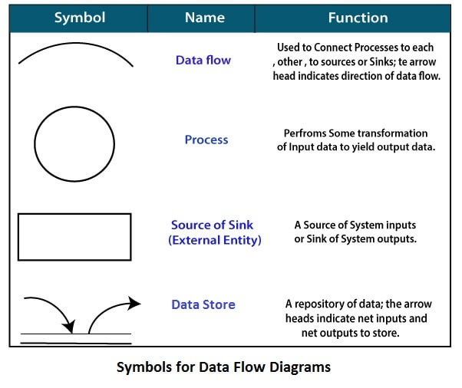

**Circle:** A circle (bubble) shows a process that transforms data inputs into data outputs.

**Data Flow:** A curved line shows the flow of data into or out of a process or data store.

**Data Store:** A set of parallel lines shows a place for the collection of data items. A data store indicates that the data is stored which can be used at a later stage or by the other processes in a different order. The data store can have an element or group of elements.

**Source or Sink:** Source or Sink is an external entity and acts as a source of system inputs or sink of system outputs.

**Zero Level DFD:**

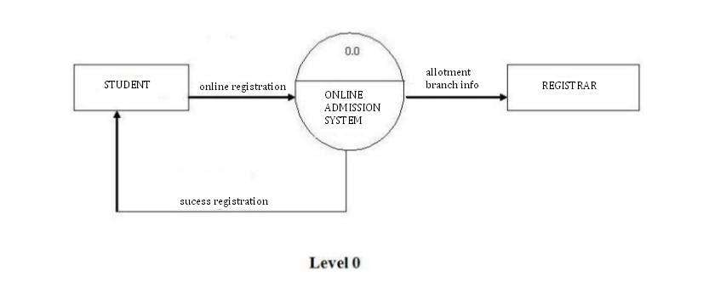

**Level 1 DFD:**

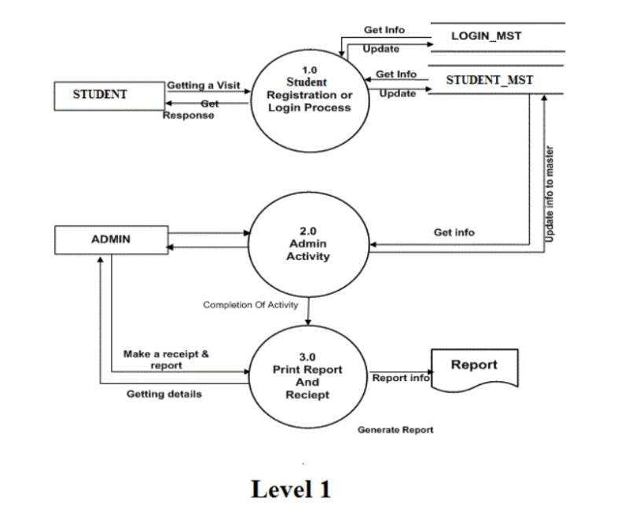

**Level 2 DFD**

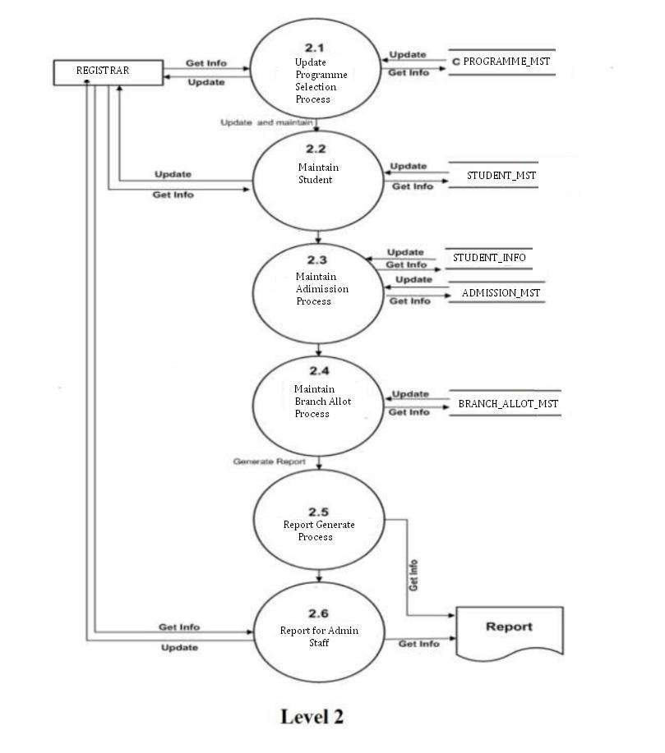

**3.2)** **Database Implementation**

MYSQL- MySQL ("My S-Q-L", officially, but also called "My Sequel") is (as of July 2013) the world's second most widely used open-source relational database management system (RDBMS). It is named after co-founder Michael Widenius daughter, My. The SQL phrase stands for Structured Query Language. The MySQL development project has made its source code available under the terms of the GNU General Public License, as well as under a variety of proprietary agreements. MySQL was owned and sponsored by a single for-profit firm, the Swedish company MySQL AB, now owned by Oracle Corporation .MySQL is a popular choice of database for use in web applications, and is a central component of the widely used LAMP opens source web application software stack (and other 'AMP' stacks). LAMP is an acronym for "Linux, Apache, MySQL, Perl/PHP/Python." Free-software-open source projects that require a full-featured database management system often use MySQL. For commercial use, several paid editions are available, and offer additional functionality. Applications which use MySQL databases Library Management System include: TYPO3, MODx, Joomla, WordPress, phpBB, MyBB, Drupal and other software. MySQL is also used in many high-profile, large-scale websites, including Wikipedia, Google (though not for searches), Facebook, Twitter, Flickr, and YouTube.

#### 3.3) ENTITY-RELATIONSHIP Diagrams

#### 

E-R (Entity-Relationship) Diagram is used to represents the relationship between entities in the table.

The symbols used in E-R diagrams are:

SYMBOL PURPOSE

Represents Entity sets.

Represent attributes.

Represent Relationship Sets.

Line represents flow

Structured analysis is a set of tools and techniques that the analyst.

To develop a new kind of a system:

The traditional approach focuses on the cost benefit and feasibility analysis, Project management, and hardware and software selection a personal considerations.

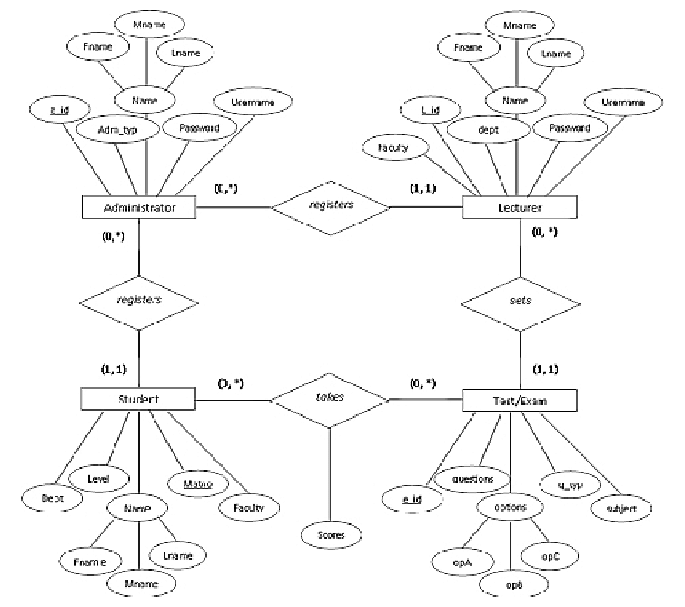

**3.4) Class Diagram:**

The class diagram shows a set of classes, interfaces, collaborations and their relationships.

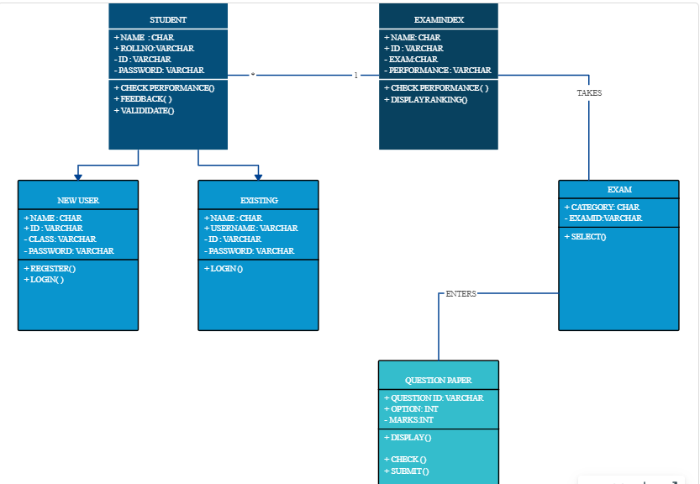

**3.5) Use Case flow Diagram**

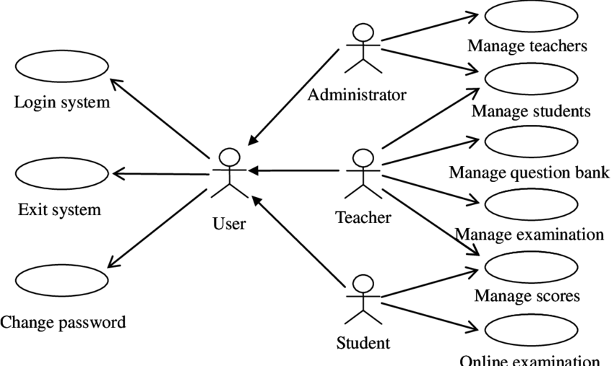

**USER MANUAL**

**4.1 USER INTERFACE DESIGN (Output Screen of Project)**

**Home Page**

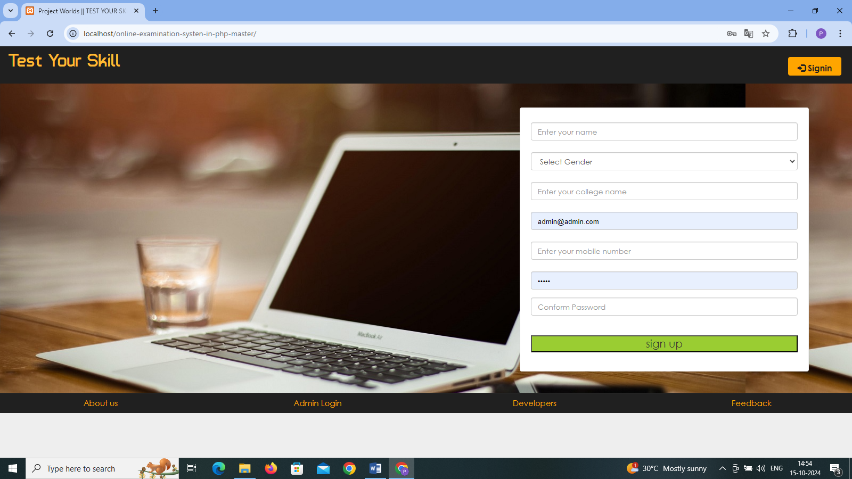

**Admin login:**

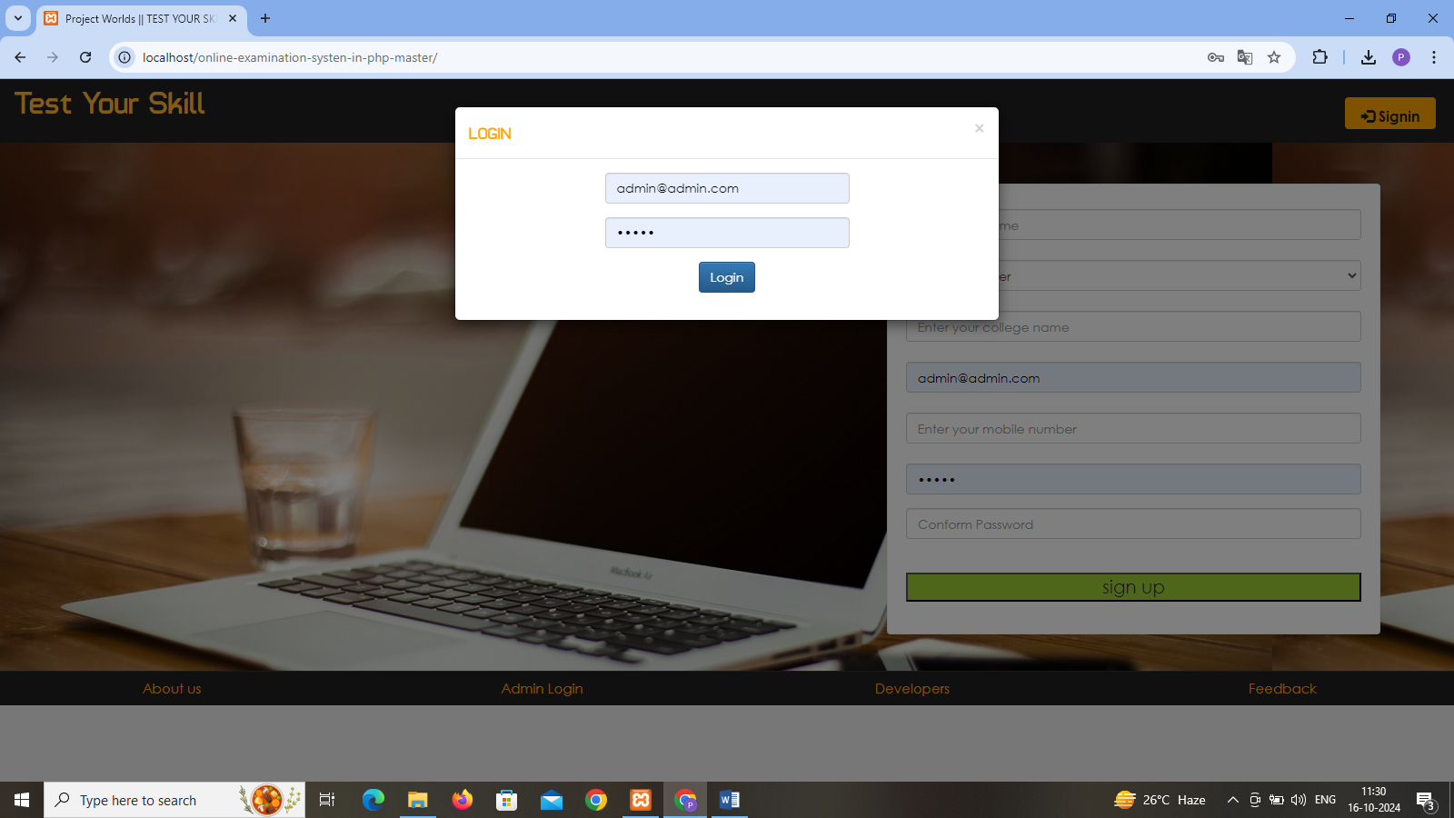

**Admin Login Home Page**

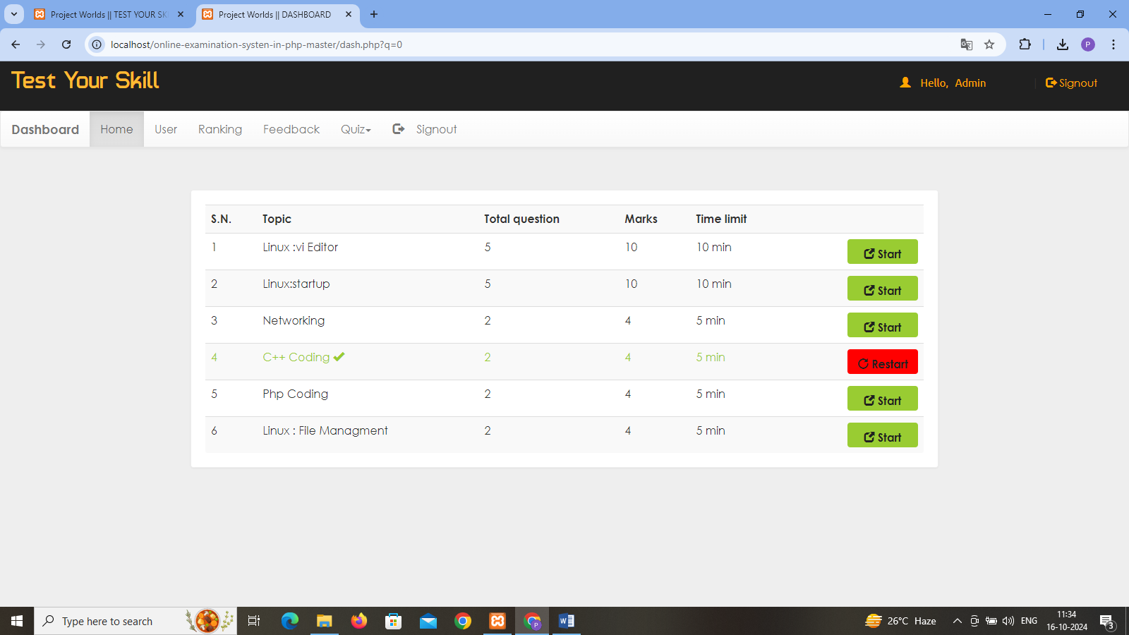

**Login Users Details**

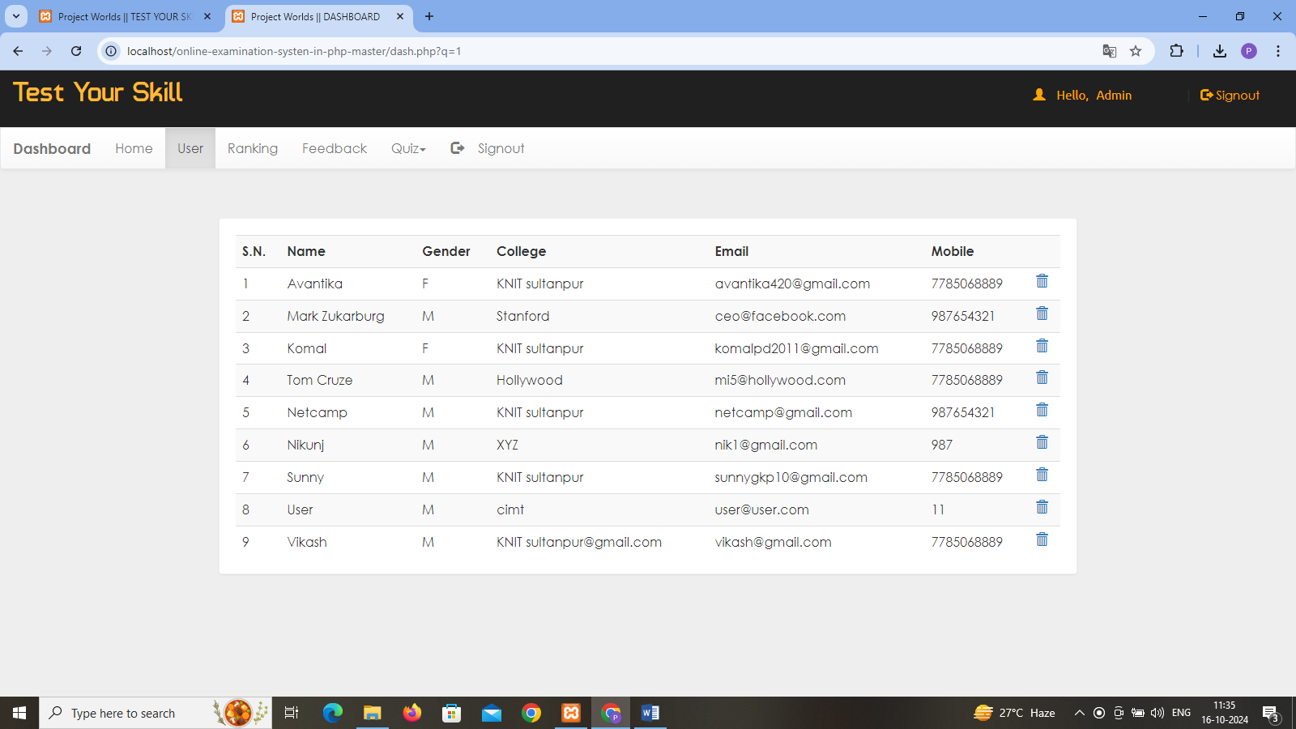

**Start Test**

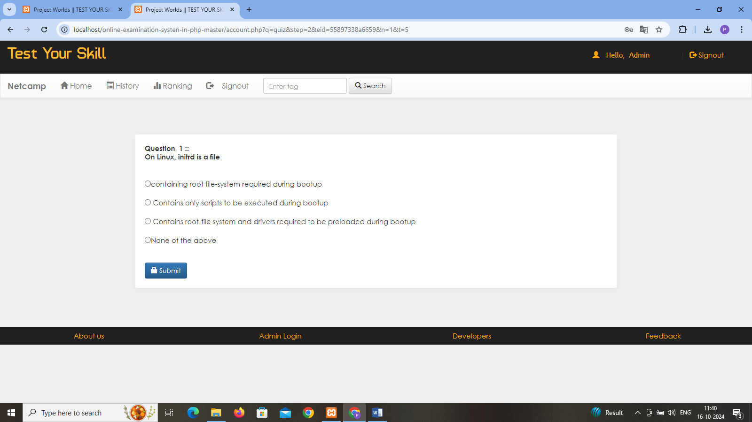

**End Exam**

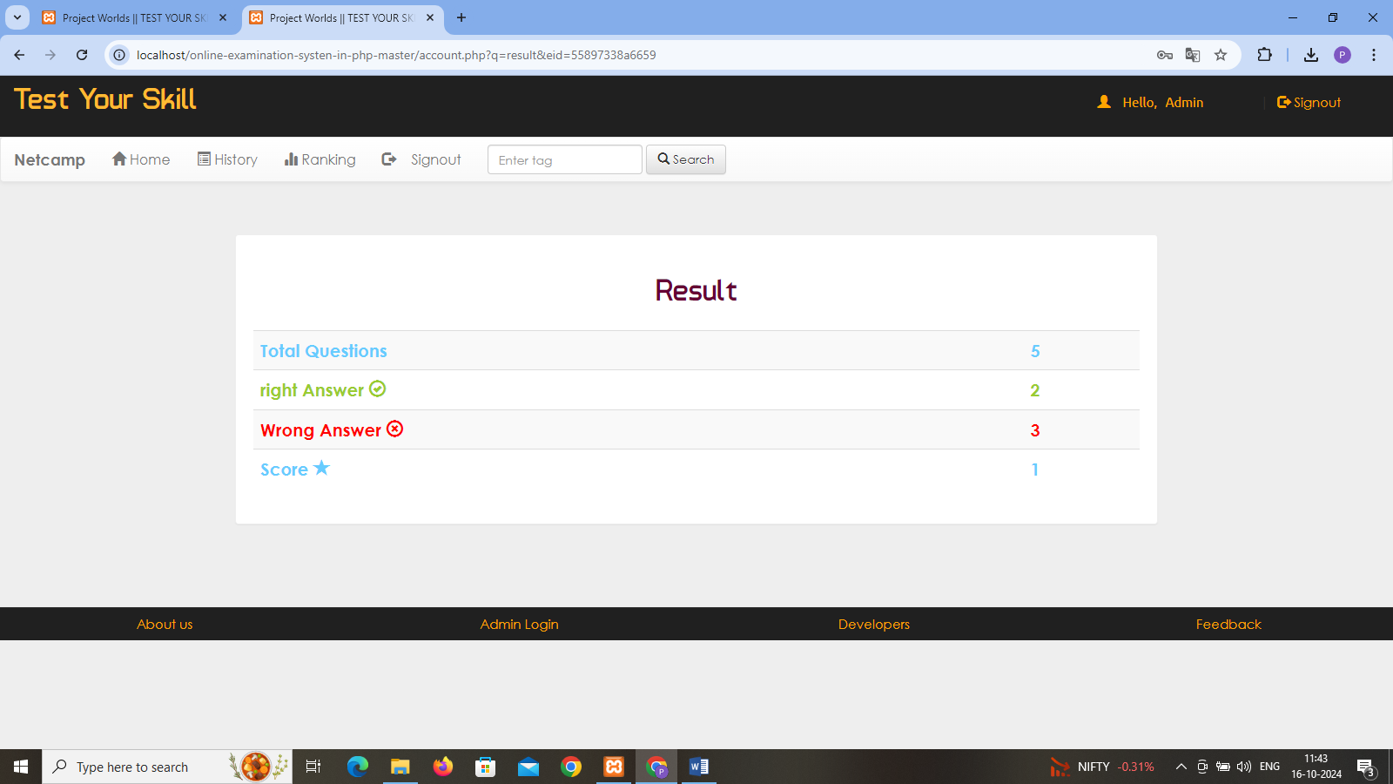

**History**

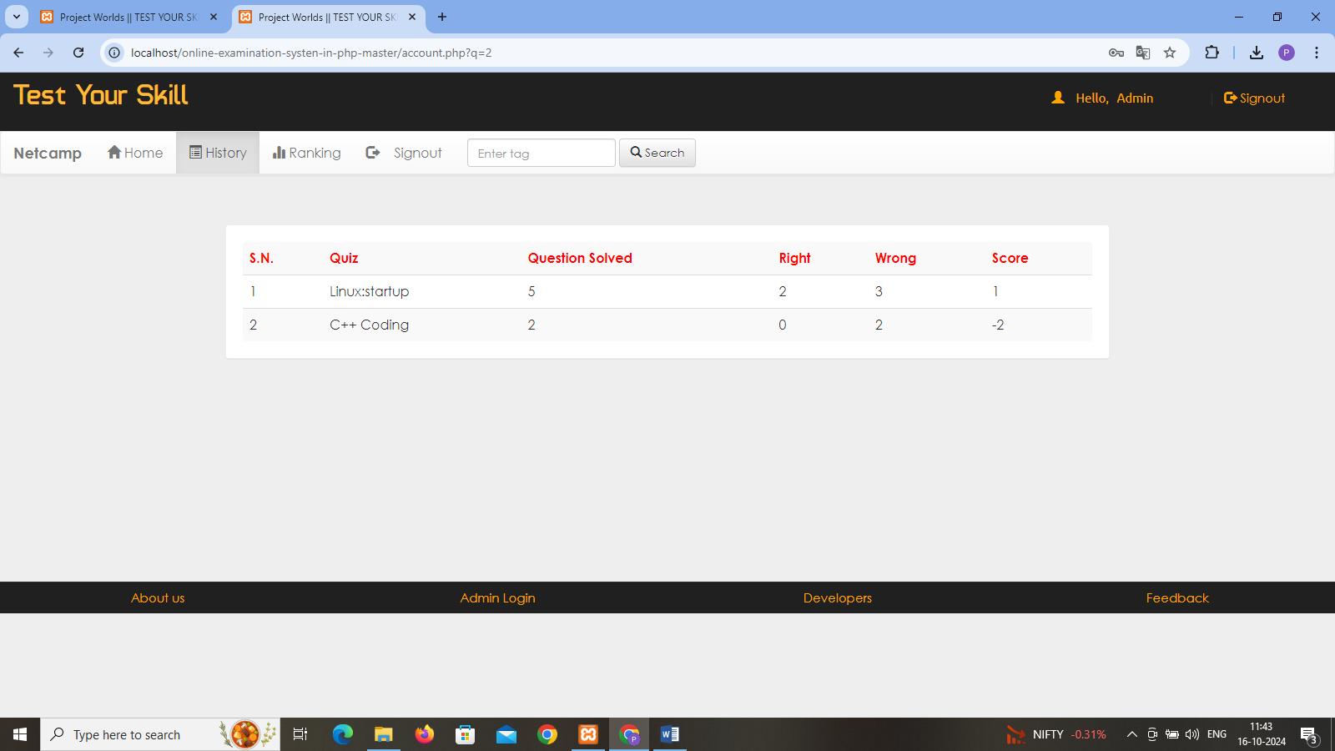

**User Score Card Data**

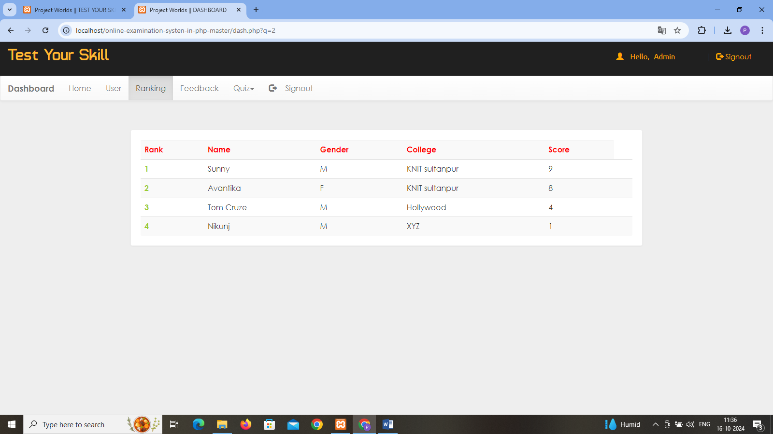

**Users Feedback Data**

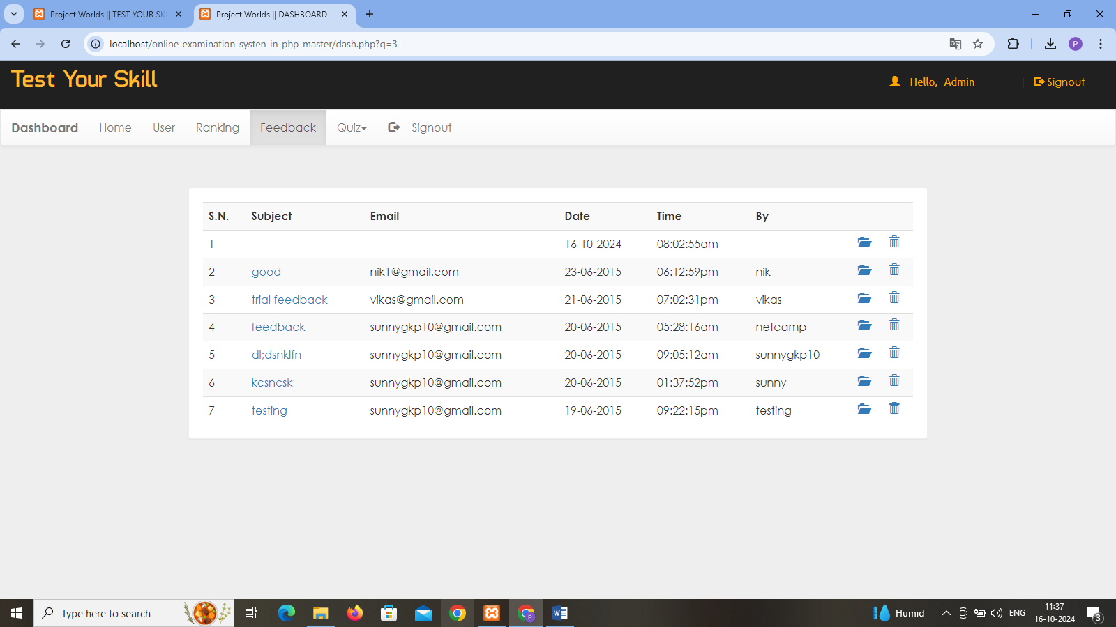

**Quiz Details Add/Remove**

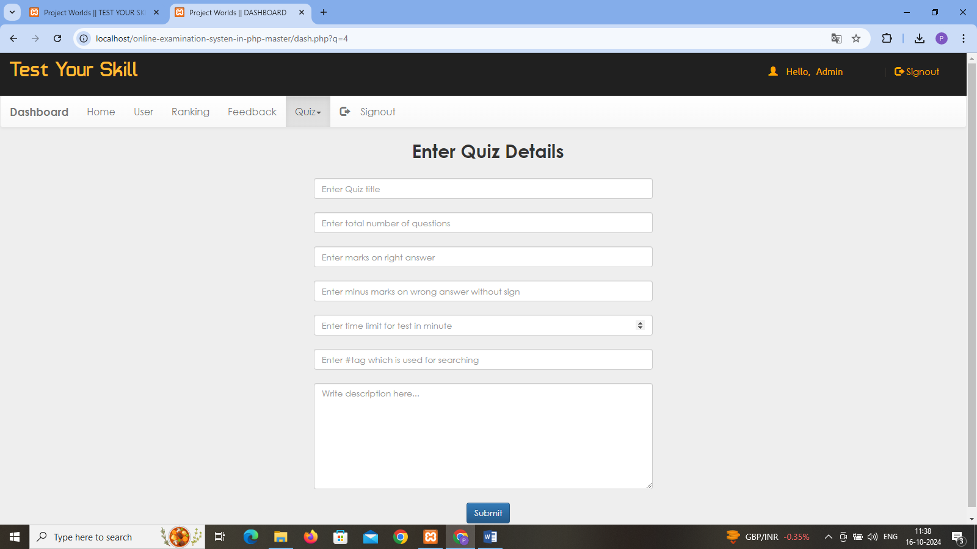

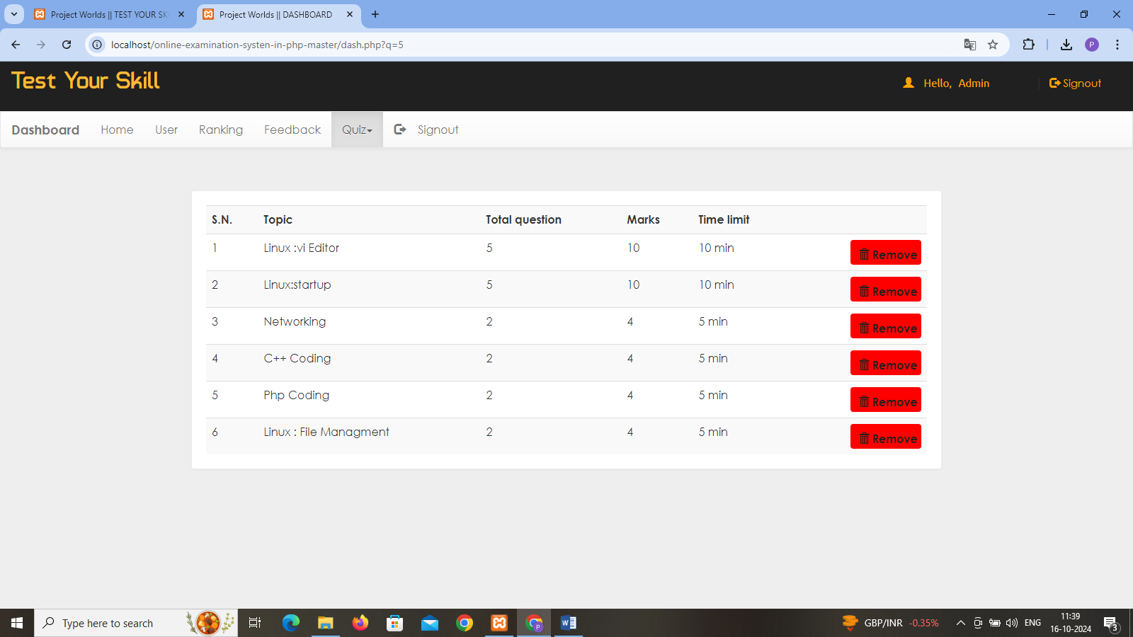

**Developer**

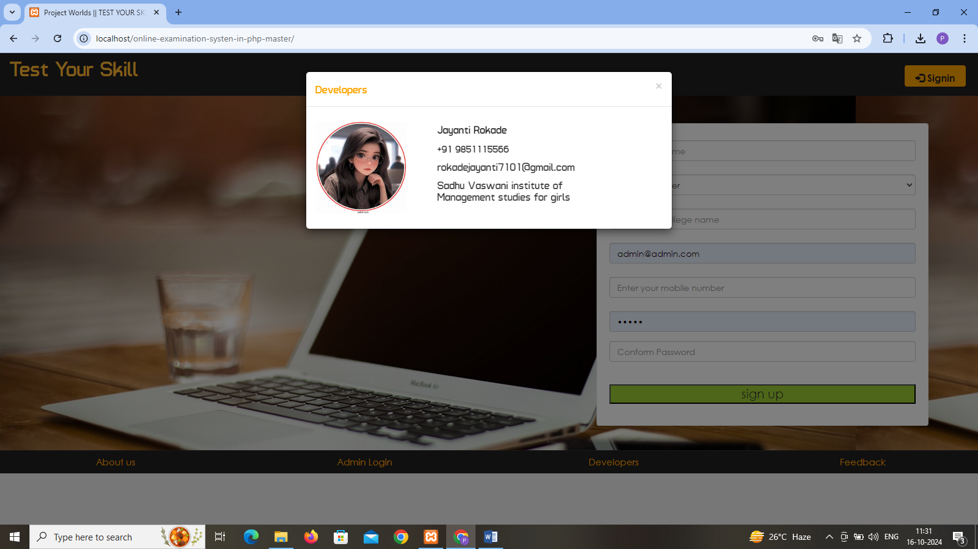

**Feedback form**

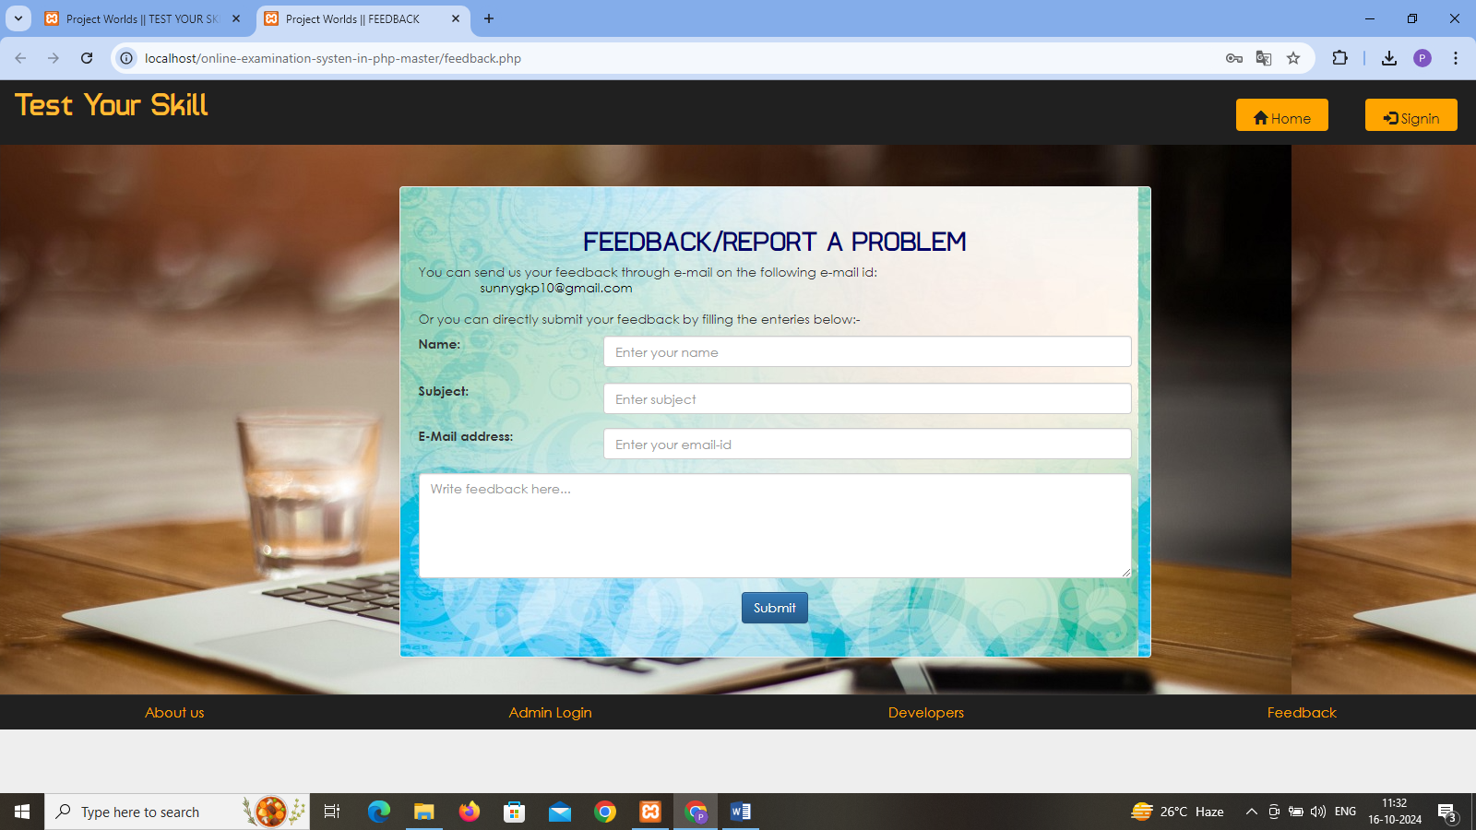

**Feedback submit**

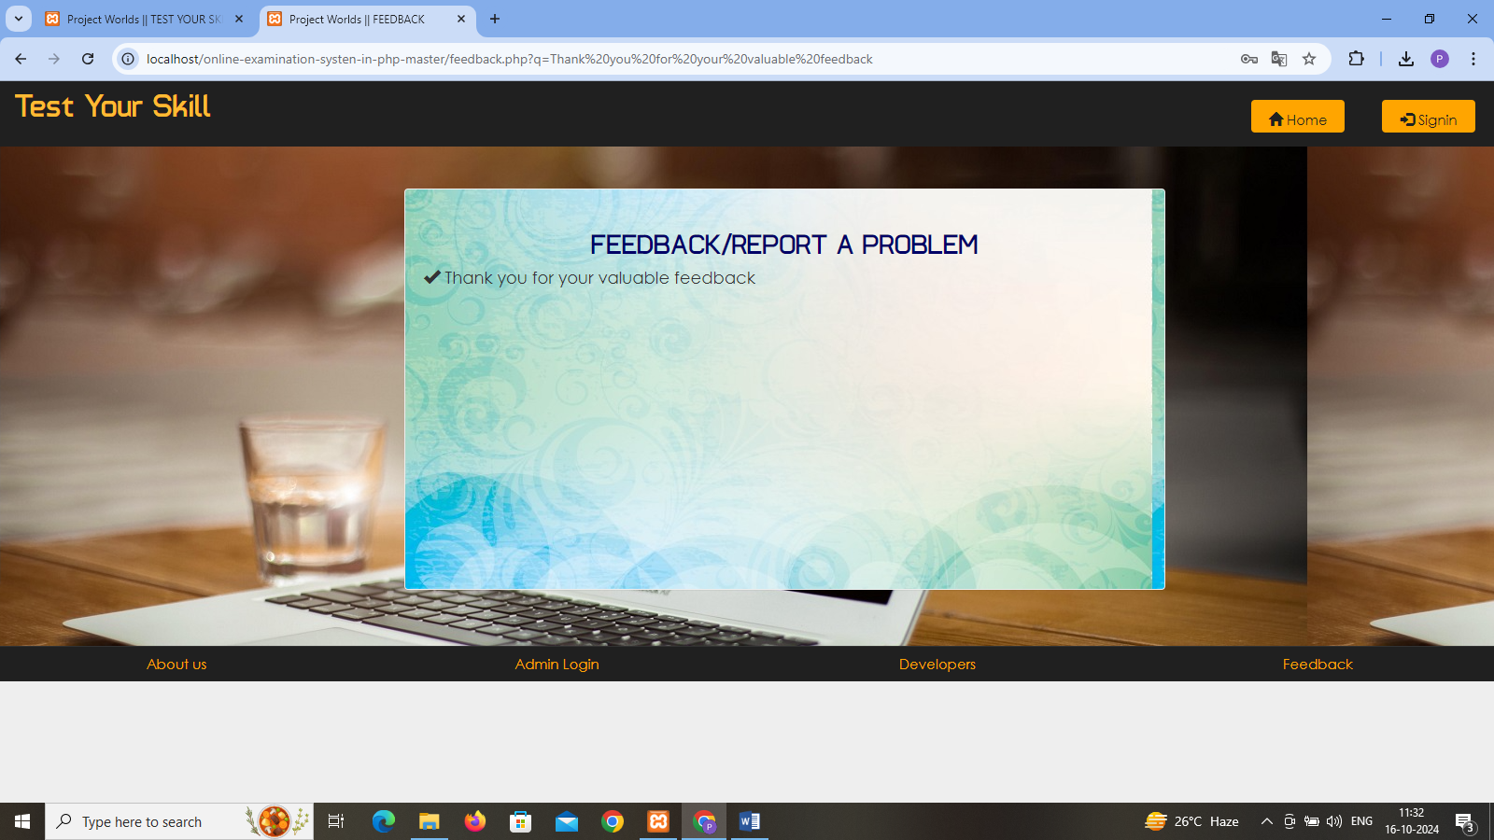

**4.2 Limitations**

Online examination management systems (OEMS) offer numerous advantages, but they also come with several limitations:

1. **Technical Issues**: System outages, software bugs, or hardware failures can disrupt examinations, causing stress for both students and administrators.
2. **Accessibility**: Not all students have reliable internet access or the necessary devices, which can create inequities in the examination process.
3. **Security Concerns**: There are risks of cheating, data breaches, and unauthorized access, which can undermine the integrity of the examination.
4. **Limited Interaction**: Online exams may lack the personal interaction that can be beneficial for both students and instructors, affecting engagement and communication.
5. **User Experience**: Poorly designed interfaces can lead to confusion and frustration, impacting students’ performance.
6. **Assessment Variety**: Some types of assessments (e.g., practical’s, oral exams) may not translate well to an online format.
7. **Monitoring Challenges**: Ensuring exam integrity can be difficult, as proctoring solutions (if implemented) may not always be foolproof.
8. **Technical Literacy**: Students with varying levels of comfort with technology may face challenges, impacting their performance.
9. **Limited Feedback**: Automated grading systems might not provide nuanced feedback, which can hinder learning and improvement.
10. **Compliance and Regulations**: Different regions may have varying regulations concerning online examinations, complicating implementation.

**4.3) Future Enhancement :**

Enhancing online examination management systems (OEMS) can improve their effectiveness and user experience. Here are some potential future enhancements:

1. **Advanced Proctoring Solutions**: Implement AI-driven proctoring tools that can monitor for suspicious behavior without invading privacy, combining facial recognition, browser monitoring, and anomaly detection.
2. **Adaptive Assessments**: Use adaptive testing algorithms that adjust the difficulty of questions based on the student’s performance in real-time, providing a more personalized assessment experience.
3. **Multi-Device Compatibility**: Ensure that the system is fully functional across various devices (smartphones, tablets, laptops) to accommodate different user preferences and accessibility needs.
4. **Gamification**: Introduce gamification elements, such as badges or leaderboards, to increase engagement and motivation among students.
5. **Real-Time Analytics**: Provide detailed analytics for educators, allowing them to track student performance trends and identify areas needing improvement.
6. **Integration with Learning Management Systems (LMS)**: Enhance interoperability with popular LMS platforms to streamline workflows and data management.
7. **User-Friendly Interface**: Continuously refine the user interface to ensure it’s intuitive, accessible, and visually appealing, minimizing confusion during exams.
8. **Offline Exam Capability**: Develop options for students to take exams offline with secure syncing capabilities to submit answers once online.
9. **Feedback Mechanisms**: Incorporate real-time feedback options, enabling students to receive insights into their performance immediately after the exam.
10. **Data Security Enhancements**: Invest in robust cybersecurity measures to protect sensitive student data and ensure compliance with regulations.
11. **Customizable Exam Formats**: Allow educators to create a variety of exam formats, including open-ended questions, project submissions, and oral presentations.
12. **Enhanced Collaboration Tools**: Facilitate collaborative assessments, where students can work in groups on projects or presentations within the online platform.
13. **Mobile App Development**: Create dedicated mobile applications to provide a seamless experience for students taking exams on the go.

**Bibliography**

For PHP

<https://www.w3schools.com/php/default.asp>

<https://www.sitepoint.com/php/>

<https://www.php.net/>

For MySQL

<https://www.mysql.com/>

[http://www.mysqltutorial.org](http://www.mysqltutorial.org/)

For XAMPP

<https://www.apachefriends.org/download.html>